7 UI/UX mistakes that SCREAM you’re a beginner
Intro
0:00
I've spent years making bad designs, so
0:02
I can tell you exactly what makes
0:03
something look like it was made by a
0:05
beginner. By the end of this video,
0:07
you'll be able to spot those mistakes
0:08
instantly and fix them just as fast.
0:11
We'll look at real examples, before and
0:13
afters, and easy ways to improve a UI
0:15
without starting from scratch. We're
0:17
going to redesign this simple recipe app
0:19
one mistake at a time until it looks
0:21
polished and production ready. Mistake
User Flow
0:23
number one, user flow. Let's start with
0:26
something that quietly ruins your UX,
0:28
user flow. Here's our allergy screen
0:30
with six preset options, but no search
0:33
bar if someone's allergic to something
0:34
else. We also don't have a skip button
0:37
either. What if the user doesn't have
0:39
any allergies? These are things you will
0:41
miss if you don't plan out your flow,
0:42
but users, they'll feel it instantly.
0:45
So, even something as simple as
0:46
sketching boxes on paper helps you catch
0:48
major gaps early on. And it's not just
0:51
all about big stuff. Little touches like
0:53
a filter icon on the search bar or a
0:55
save button up top go a long way. The
0:58
most commonly missed elements,
0:59
navigation links, hidden states, and
1:01
dynamic interactions like button hovers
1:04
or micro interactions. Mistake number
Overusing Effects
1:06
two, overusing effects. Early on, I was
1:09
addicted to visual effects. Shadows,
1:12
glows, gradients, you name it. But the
1:14
truth, overusing them can make your
1:16
designs feel cluttered and amateur.
1:18
Let's start with the gradient here. It's
1:20
blue and green, and it's just not
1:23
working. If you really need a gradient,
1:25
stick to variations of the same color,
1:27
like a darker or lighter green. But
1:29
honestly, this would look way cleaner
1:31
with no gradient at all. And that's
1:33
usually the case. Now, let's talk drop
1:35
shadows for a second. These Figma
1:37
defaults are way too harsh. Instead of
1:40
just lowering opacity, I change the
1:42
entire shadow color, usually to a light
1:44
gray, and increase the blur
1:46
significantly. Or once again, remove the
1:49
shadow completely. Because most of the
1:51
time, less visual noise equals a better
1:54
design. Mistake number three, spacing.
Spacing
1:57
Most beginner UIs are packed way too
1:59
tight, like my old app design. So, I'll
2:01
use two tools here, grids and auto
2:03
layout to make it so much better. First,
2:05
we'll set up a three column grid for
2:07
this screen and two column grid here
2:09
with these measurements. Now, just align
2:11
elements to the grid as closely as
2:13
possible. If something needs to break
2:15
the grid slightly, like these elements,
2:17
just leave it as is if it still feels
2:19
balanced. Next, for stack content like
2:21
this, increase the vertical spacing to
2:23
let things breathe and group naturally,
2:25
especially on mobile screens, you'll
2:27
need more space than you think. Now,
2:29
check out these cards and chips. The
2:31
layouts are pretty wonky. Perfect time
2:33
to use auto layout. Turn off vertical
2:36
trim for pixel perfect control and
2:38
adjust spacing like this. Repeat this
2:40
across your UI to keep spacing
2:42
consistent and clean, which is a perfect
2:45
segue into the next mistake most
2:47
designers make. Mistake number four,
Inconsistent Components
2:49
inconsistent components like spacing.
2:52
This one kills me since it's just so
2:54
easy to fix. You'll notice throughout
2:55
our design, we have all sorts of
2:57
different corner radiuses and components
3:00
like this back and skip button that are
3:02
exactly the same but designed
3:04
differently, which just makes the design
3:06
feel amateur. Instead, let's make a few
3:08
changes. First, we'll make the two
3:10
search bars identical other than the
3:12
prompting text. We'll set the corner
3:14
radius of all smaller components to be
3:16
10 pixels. This is an important one that
3:18
most designers miss. And of course,
3:21
we'll update the skip button and back
3:22
button to match in size, corner radius,
3:24
and style. Being consistent means using
3:27
styles for colors, variables for
3:29
measurements, and components for UI
3:31
elements to really bring your design
3:32
together. Mistake number five, icons. I
Icons
3:36
think people underestimate how much good
3:38
icons do for a design and how
3:40
detrimental bad icons are. First of all,
3:43
we have no icons on these cards here,
3:46
which forces users to read more and
3:48
slows down the browsing process. Let's
3:50
add in some good icons and replace the
3:52
save text. Then up above, we have icons,
3:55
but they're mismatched in fill, line
3:57
width, and style. We can fix this by
3:59
using the same library of icons like
4:02
flat icons. On their website, select
4:04
interface icons and then sort by stroke,
4:06
width, and corner to get some consistent
4:08
results. Make sure when you download to
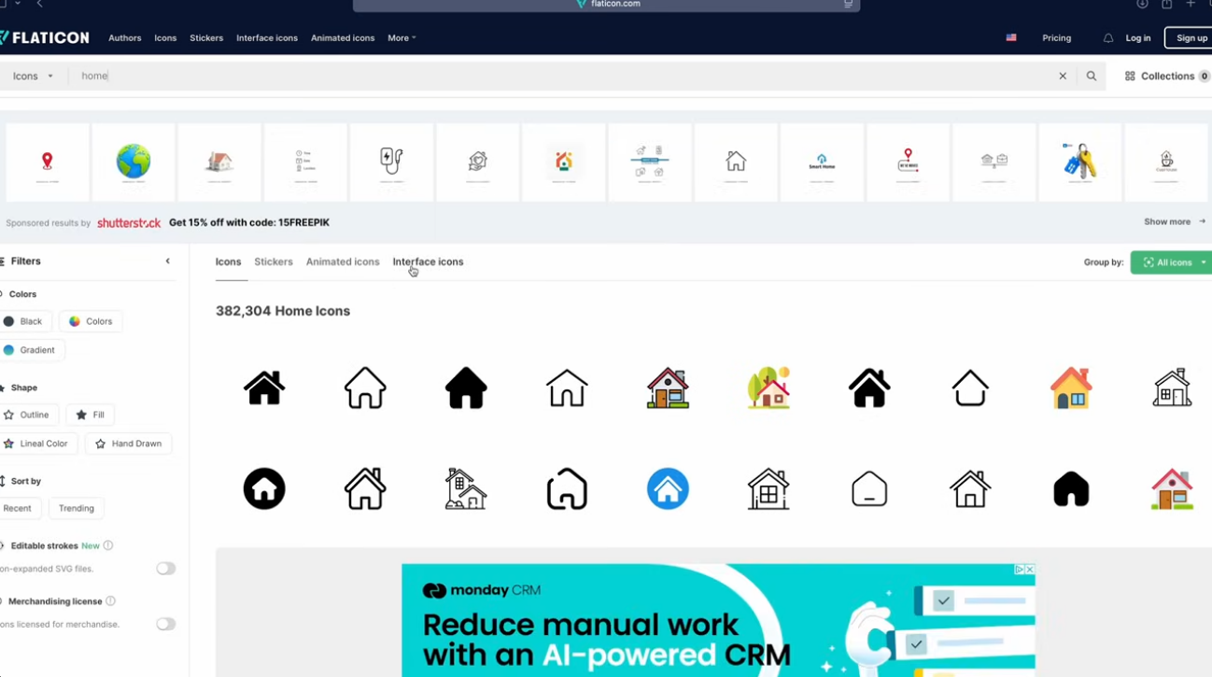
4:10
grab SVG for the best results. If you
4:13
want to choose a Figma plugin instead, I
4:15
like feather icons and phosphor icons.
4:18
Finally, we have a fair amount of icons
4:20
down here without labels. If the icons
4:22
are wellknown enough, like the house,
4:24
bookmark, and user, then you don't need
4:26
to have anything, but for these two, a
4:28
tool tip pop-up could make the
4:30
onboarding process much smoother. Just
4:32
try not to have bizarre icons
4:34
everywhere. Finally, this is a very pro
4:36
tip, but interestingly, it is okay to
4:39
have different styles of icons in the
4:41
same design, but only if they're
4:42
visually separate. For example, these
4:44
navbar icons are slightly different than
4:47
the food icons, and those are different
4:48
than our recipe icons, but it all works
4:51
together since they're in separate areas
4:52
of our design and used for different
4:54
things. Mistake number six, redundant
Redundant Elements
4:57
elements. Having redundant elements is
4:59
actually a really common mistake,
5:01
especially as the trend of having stuff
5:03
everywhere takes over. Looking at this
5:05
screen, we can get rid of this arrow
5:07
since we'll be able to swipe on mobile.
5:09
And same idea down below. We can also
5:11
get rid of this arrow since it's really
5:13
just visual clutter and dim down the
5:15
color of the button. You could probably
5:16
argue that these arrows aren't needed
5:18
either, but we are going to keep those.
5:20
Finally, the stroke on these elements is
5:22
really not needed. If you are worried
5:24
about contrast ratios, dimming it down
5:26
significantly is a good option, too, but
5:29
we'll just rip them straight out.
5:30
Mistake number seven, interactive
Interactive Feedback
5:32
feedback. We've covered overusing
5:34
effects. So, now let's cover the
5:36
underuse of different interactive
5:38
effects. For example, if we're
5:39
navigating through our flow, but it
5:41
takes a split second longer for the next
5:43
screen to load, it looks like we haven't
5:45
even clicked on the button at all. But
5:47
if we make it grayed out when we click
5:48
on it, we've added some interaction and
5:50
it shows the user that the next screen
5:52
is coming. Even better, we could add a
5:55
loading wheel if it's really taking a
5:56
long time. Another good example is
5:58
clicking on this save icon. Filling it
6:01
in is a great first step, but we could
6:02
also add a red dot to our save tab. So,
6:05
when we click on the icon, we get it
6:07
filled in and it's clear to the user
6:09
that there's a new recipe added to the
6:10
save tab. We've actually made an entire
6:13
video just about interactive feedback
6:15
and micro interactions, so check out
6:17
that video afterwards to see some really
6:19
smooth animations. Bonus mistake number
Charts
6:22
eight, charts. This is a bonus tip since
6:25
it has nothing to do with our recipe
6:26
app, but charts are so often messed up
6:29
by overdesigning the thing that I
6:31
thought I should make a point to mention
6:32
it. I have two charts here. Which one do
6:35
you think I got from Dribble? The one on
6:36
the right. Yes. And it's basically
6:38
impossible to read without any vertical
6:40
axis. And even if we had a vertical
6:43
axis, it's hard to tell where the bar
6:44
ends with a rounded top. And then there
6:46
are 16 bars here, but only 7 days of the
6:49
week. Why would you do that? Whereas the
6:51
one on the left is simple, definitely
6:53
less aesthetic, but conveys so much more
6:56
useful information to the user. And that
Outro
6:58
is everything you'll need to start
7:00
spotting and correcting beginner
7:02
mistakes. The Figma file with the
7:04
mistakes and the full app is in the link
7:06
in description. Other than that, thank
7:08
you so much for watching and I'll see
7:09
you in the next one.
7:11
[Music]

